CURRICULUM VITAE
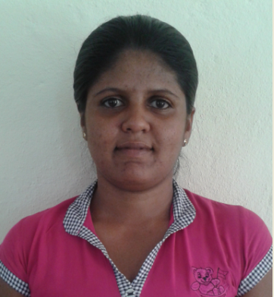
J.W.C DILANI
Nadugalahena,Rathkekulawa,Ransegoda,South,Matara.
Tel : 0717549110
E-mail : Chamiladilani90@gmail.com

STRENGTHS
- Capable to cope up with new system upgrades easily.
- Highly reliable and responsible pertaining to the matters of work.
- Performance oriented and hardworking.
- Resourceful and believes in continuous learning and improvement.
- Good at team working.

OTHER QUALIFICATIONS

Successfully completed the certificate course in Lanaka National computer College, Matara Following Courses are

- Office Appilication

Successfully completed the certification course in University of Colombo,Sripalee Campus Following course are
- Graphic Design
- Office application.
Following tamil six month course in Maharagama Youth Center
Daham Pasal ( dhamma school) Final Examination -2007

ACADEMIC QUALIFICATIONS

- I’m a Under graduate of University of Colombo in Faculty of Mass Media.

- Passed G.C.E.(Advanced Level) Examination in Year 2010

Subject Grade
Sinhala A
Geographic B
Political Science B

- Passed G.C.E. (Ordinary Level) Examination in Year 2006,2007.

Subject Grade
Buddhism A
Health & Phy: A
Soc. St. & His. C
Music C
Sinhala C
Mathematics C
English C
Geography C
Home Sci. & Eco C
Science & Tec. B

EXTRA-CURRICULAR ACTIVITIES

- I was a member of School Prefect Board in year 2006
- I was a member of Dhaham Pasal Prefect Board 2004-2007
- Completed the Leader ship training program, held by The Ministry of Higher Education
- Internship in Transpreancy International Sri Lanka (TISL).

PERSONAL DETAILS

- Name in full : Jayavickarama Withanage Chamila Dialni
- Date of Birth : 30th of Agu 1990
- Gender : Female
- Civil Status : Single
- N.I.C.No : 907430170V
- Nationality : Sri Lankan
- Religion : Buddhist

.
DECLARATION

I can assure you that the above information furnished about me is in perfect truthfulness and can be proved at any time required.

